Code Translation: Converting Between Programming
Languages
NAME: Shaik Afrid
ROLL.NO: 2503A52385
Batch-13
Task 1 – Python to Java Conversion
Task:
Translate a simple Python class into Java using AI assistance.
Instructions:
Prompt AI to convert a Python class with attributes and
methods into equivalent Java code.
Verify that constructors, method signatures, and data types
are properly handled.
Run both versions (Python &amp; Java) to compare expected
outputs.
Expected Output:
Equivalent working Java class translated from Python.
PROMPT:
Convert this Python Student class into equivalent Java code with constructor and display method.
PYTHON CODE:
class Student:
def __init__(self, name, age, course):
self.name = name
self.age = age
self.course = course
def display(self):
print('Name:', self.name)
print('Age:', self.age)
print('Course:', self.course)
s = Student('Shaik Afrid', 21, 'AI & ML')
s.display()
OUTPUT:
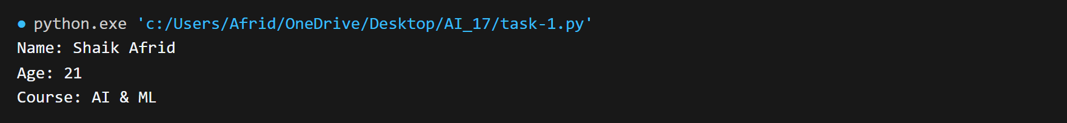
JAVA CODE:
class Student {
String name;
int age;
String course;
Student(String name, int age, String course) {
this.name = name;
this.age = age;
this.course = course;
}
void display() {
System.out.println('Name: ' + name);
System.out.println('Age: ' + age);
System.out.println('Course: ' + course);
}
public static void main(String[] args) {
Student s = new Student('Shaik Afrid', 21, 'AI & ML');
s.display();
}
}
OUTPUT:
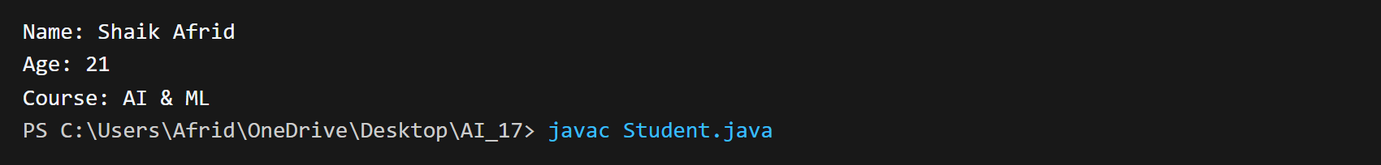
Task 2 – C++ to Python Function Conversion
Task:
Convert a C++ function for factorial calculation into Python.
Instructions:
Ask AI to translate a recursive C++ factorial function into
Python.
Validate correctness by testing with sample inputs.
Ensure Python version follows Pythonic conventions.
Expected Output:
A correct Python implementation equivalent to the original
C++ factorial function.
PROMPT:
Convert this recursive C++ factorial function into Python.
CODE:
def compute_factorial(n):
if n <= 1:
return 1
return n * compute_factorial(n - 1)

number = 6
print('Factorial of', number, 'is:', compute_factorial(number))

OUTPUT:

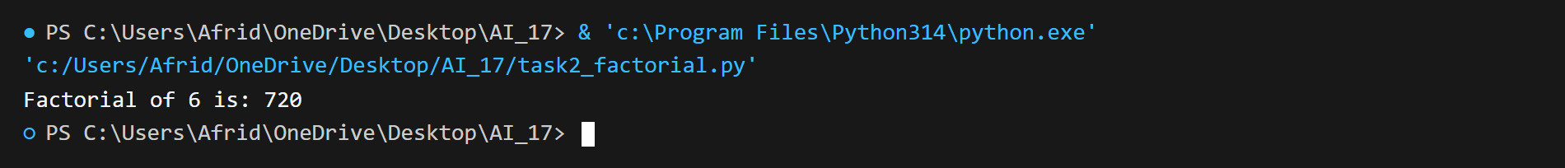
Task 3 – SQL to Pandas Query
Task:
Translate a SQL query into a Pandas DataFrame operation in
Python.
Instructions:
Provide AI with a SQL query (e.g., SELECT name, salary
FROM employees WHERE salary &gt; 50000).
Ask AI to generate equivalent Pandas code.
Test the generated code on a sample DataFrame.
Expected Output:
Equivalent Pandas query that retrieves the correct subset of
data.
PROMPT:
Convert this SQL query into equivalent Pandas code and test it using a sample DataFrame.
CODE:
import pandas as pd

data = {
'emp_name': ['Afrid', 'Rahul', 'Sneha', 'Vikram', 'Ananya'],
'department': ['AI & ML', 'Cloud', 'DevOps', 'Cybersecurity', 'Data Science'],
'salary': [65000, 48000, 72000, 52000, 80000]
}
df = pd.DataFrame(data)

result = df[df['salary'] > 50000][['emp_name', 'department', 'salary']]

print(result)
OUTPUT:
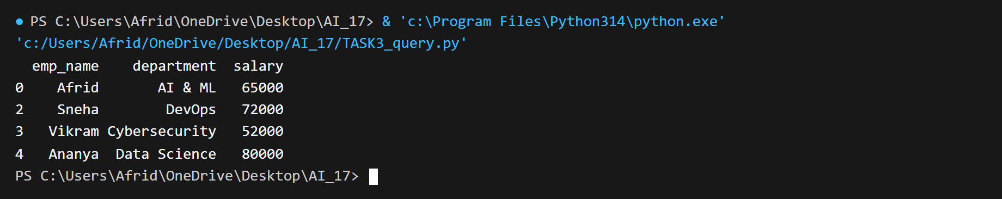

Task 4 – Real-Time Application: Multi-Language Snippet
Converter
Scenario:
Students will choose a real-time use case where they need code in
multiple languages. Example:
Converting a Python web scraping snippet into JavaScript
for browser automation.
Translating a Java method into C# for enterprise
applications.
Instructions:
Prompt AI to translate code between two chosen languages.
Test both implementations to ensure they produce the same
results.
Document challenges faced during translation (e.g., syntax,
libraries).
Expected Output:
Working equivalent code snippets in at least two different
programming languages.
PROMPT:
Convert this Python cube function into JavaScript and verify that both produce the same output.
PYTHON CODE:
def calculate_cube(n):
return n ** 3

num = 4
print('Cube of', num, 'is:', calculate_cube(num))

OUTPUT:

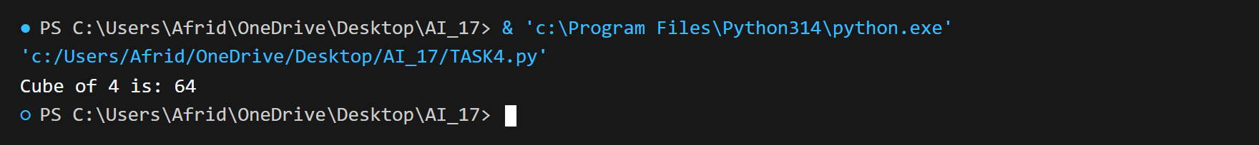
JAVASCRIPT CODE:
function calculateCube(n) {
return Math.pow(n, 3);
}

let num = 4;

console.log('Cube of ' + num + ' is: ' + calculateCube(num));
OUTPUT:

